**LAB 10**

**Advanced Procedures**





EL

-

2003

COMP ORG & A

SSEMBLY LANG

LAB

LABORATORY MANUAL



FALL 2021 Instructors: Aamir Ali, Aashir Mehboob, Amin Sadiq,Quratulain, M Kariz, Rabia



Mohammad Yehya Hayati K213309 G

________________________________________ __________ ___

STUDENT NAME ROLL NO SEC

______________________________________

# LAB ENGINEER'S SIGNATURE & DATE

**MARKS AWARDED: /**

_________________________________________________________________

**NATIONAL UNIVERSITY OF COMPUTER AND EMERGING SCIENCES**

**(NUCES), KARACHI**

**Prepared by: Qurat ul ain**

# Lab Session 10: Advanced Procedures

**Learning Objectives**

* Implementing procedures using stack frame
* Using stack parameters in procedures
* Passing value type and reference type parameters

# Stack Applications

There are several important uses of runtime stacks in programs:

1. A stack makes a convenient temporary save area for registers when they are used for more than one purpose. After they are modified, they *can* be restored to their original values.
2. When the CALL instruction executes, the CPU saves the current subroutine’s return address on the stack.
3. When calling a subroutine, you pass input values called arguments by pushing them on the stack.
4. The stack provides temporary storage for local variables inside subroutines.

# Stack Parameters

## • Passing by value

When an argument is passed by value, a copy of the value is pushed on the stack. **EXAMPLE # 01:**

.data

var1 DWORD 5

var2 DWORD 6

.code push var2 push var1 call AddTwo exit

AddTwo PROC push ebp mov ebp, esp mov eax, [ebp + 12]

add eax, [ebp + 8] pop ebp

ret

AddTwo ENDP

## • Explicit stack parameters

When stack parameters are referenced with expressions such as [ebp+8], we call them explicit stack parameters.

**Example 2:**

.data

var1 DWORD 5

var2 DWORD 6

y_param EQU [ebp + 12]

x_param EQU [ebp+ 8]

.code

push var2

push var1

call AddTwo

exit

AddTwo PROC

push ebp

mov ebp, esp

mov eax, y_param

add eax, x_param

pop ebp

ret

AddTwo ENDP

## • Passing by reference

An argument passed by reference consists of the offset of an object to be passed.

**EXAMPLE # 03:**

.data

count = 10

arr WORD count DUP (?)

.code push OFFSET arr push count

call ArrayFill exit

ArrayFill PROC push ebp mov ebp, esp pushad

mov esi, [ebp + 12] mov ecx, [ebp + 8] cmp ecx, 0 je L2 L1:

mov eax, 100h call RandomRange mov [esi], ax add esi, TYPE WORD

loop L1 L2:

popad pop ebp

ret 8

ArrayFill ENDP

# LEA Instruction

LEA instruction returns the effective address of an indirect operand. Offsets of indirect operands are calculated at runtime.

**EXAMPLE # 04:**

.code call makeArray

exit

makeArray PROC push ebp mov ebp, esp sub esp, 32 lea esi, [ebp - 30] mov ecx,30

L1:

mov BYTE PTR [esi], '*'

inc esi

loop L1

add esp, 32

pop ebp ret

makeArray ENDP

# ENTER & LEAVE Instructions

Enter instruction automatically creates stack frame for a called Procedure. Leave instruction reverses the effect of enter instruction.

**EXAMPLE # 05:**

.data

var1 DWORD 5 var2 DWORD 6

.code push var2 push var1

call AddTwo exit

AddTwo PROC

enter 0, 0 mov eax, [ebp + 12] add eax, [ebp + 8]

leave ret

AddTwo ENDP

# Local Variables

In MASM Assembly Language, local variables are created at runtime stack, below the base pointer (EBP).

**EXAMPLE # 06:**

.code

call MySub

exit

MySub PROC

push ebp

|  |  |  |  |
| --- | --- | --- | --- |
| mov | ebp, esp |  |  |
| sub | esp, 8 |  |  |
| mov | DWORD | PTR [ebp - 4], 10 | ; first parameter |
| mov | DWORD | PTR [ebp - 8], 20 | ; second parameter |
| mov | esp, ebp |  |  |
| pop | ebp |  |  |

ret

MySub ENDP

# LOCAL Directive

LOCAL directive declares one or more local variables by name, assigning them size attributes.

**EXAMPLE # 07:**

.code call LocalProc exit

LocalProc PROC LOCAL temp : DWORD mov temp, 5

mov eax, temp

ret

LocalProc ENDP

# Recursive Procedures

Recursive procedures are those that call themselves to perform some task.

**EXAMPLE # 08:**

.code L1:

mov ecx, 5

mov eax, 0 call CalcSum call WriteDec

call crlf exit

CalcSum PROC

|  |  |
| --- | --- |
| cmp | ecx, 0 |
| jz | L2 |
| add | eax, ecx |
| dec | ecx |
| call | CalcSum |

L2: ret

CalcSum ENDP

## • INVOKE Directive

The INVOKE directive pushes arguments on the stack and calls a procedure. INVOKE is a convenient replacement for the CALL instruction because it lets you pass multiple arguments using a single line of code.

Here is the general syntax:

INVOKE procedureName [, argumentList]

For example: push TYPE array push LENGTHOF array push OFFSET array call DumpArray is equal to

INVOKE DumpArray, OFFSET array, LENGTHOF array, TYPE array

## • ADDR Operator

The ADDR operator can be used to pass a pointer argument when calling a procedure using INVOKE. The following INVOKE statement, for example, passes the address of myArrayto the FillArrayprocedure: INVOKE FillArray, ADDR myArray

## • PROC Directive

Syntax of the PROC Directive

The PROC directive has the following basic syntax:

Label PROC [attributes] [USES reglist], parameter_list

The PROC directive permits you to declare a procedure with a comma-separated list of named parameters.

Example: The FillArray procedure receives a pointer to an array of bytes:

FillArray PROC,

pArray:PTR BYTE

. . .

FillArray ENDP

## • PROTO Directive

The PROTO directive creates a prototype for an existing procedure. A prototype declares a procedure’s name and parameter list. It allows you to call a procedure before defining it and to verify that the number and types of arguments match the procedure definition.

MySub PROTO ; procedure prototype

.

INVOKE MySub ; procedure call

.

MySub PROC ; procedure implementation

.

MySub ENDP

**Exercises:**

1. Write a program which contains a procedure named **BubbleSort** that sorts an array which is passed through a stack using indirect addressing.

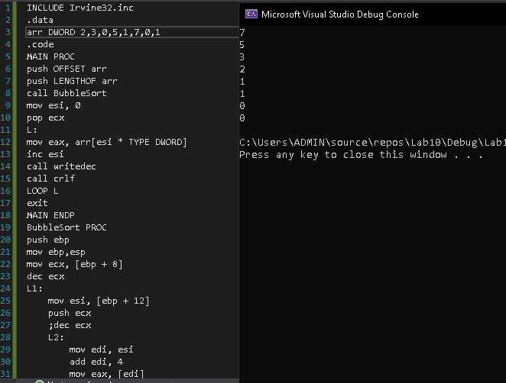

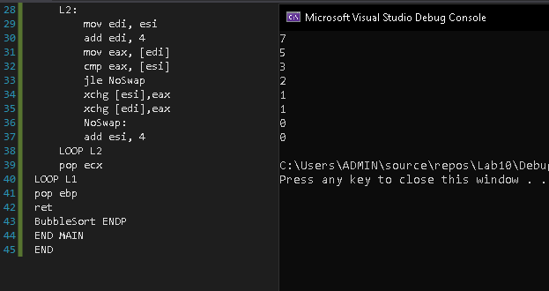

1. Write a program which contains a procedure named **TakeInput** which takes input numbers from user and call a procedure named **Armstrong** which checks either a number is an Armstrong number or not and display the answer on console by calling another function **Display**. (Also show ESP values during nested function calls)

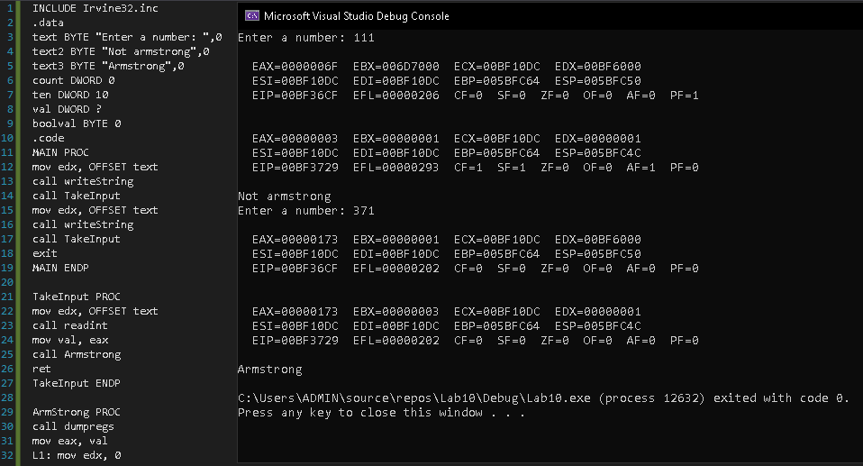

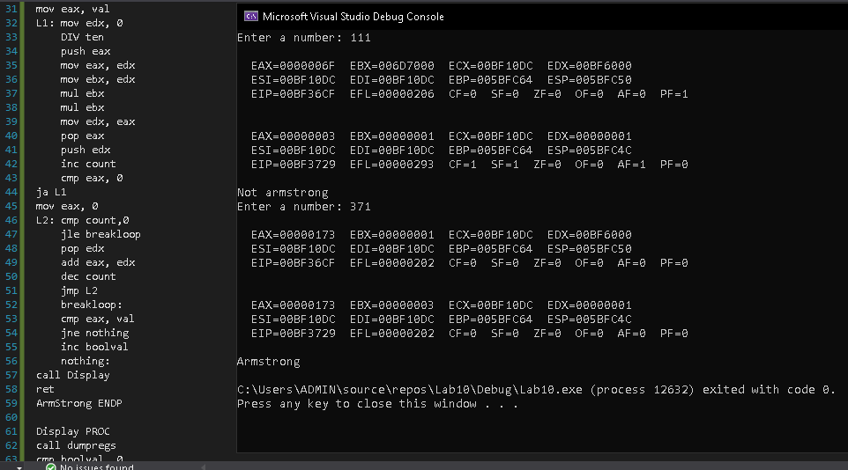

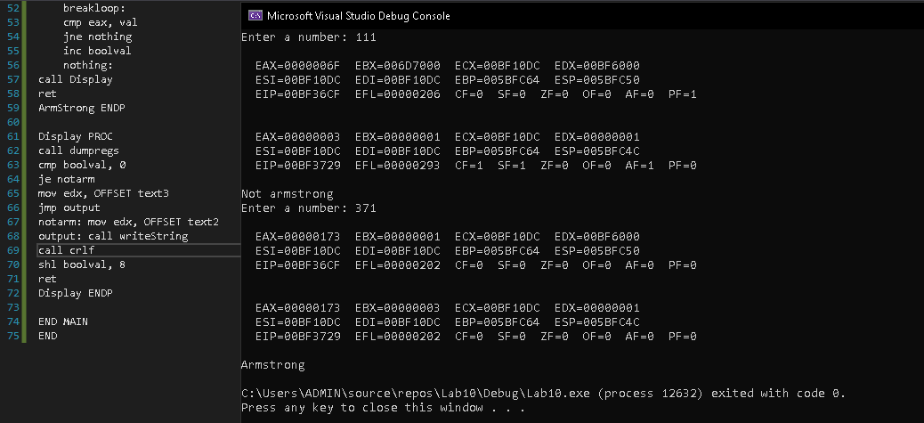

1. Write a program which contains a procedure named **Reverse** that reverse the string using recursion.

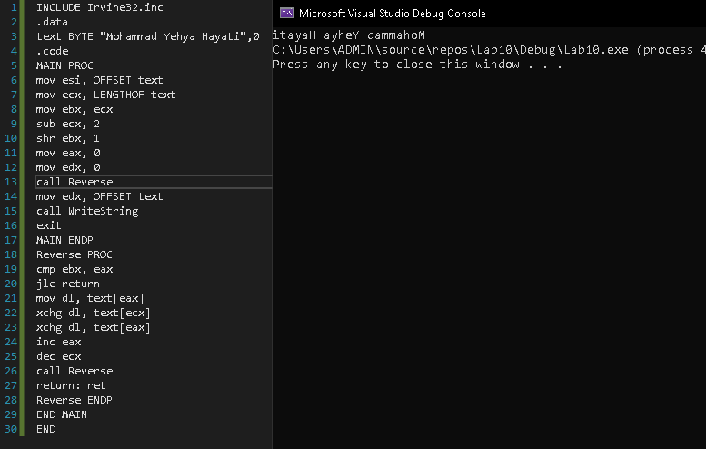

1. Write a program which contains a procedure named **LocalSquare** . The procedure must declare a local variable. Initialize this variable by taking an input value from the user and then display its square. Use **ENTER *& LEAVE*** instructions to allocate and de-allocate the local variable.

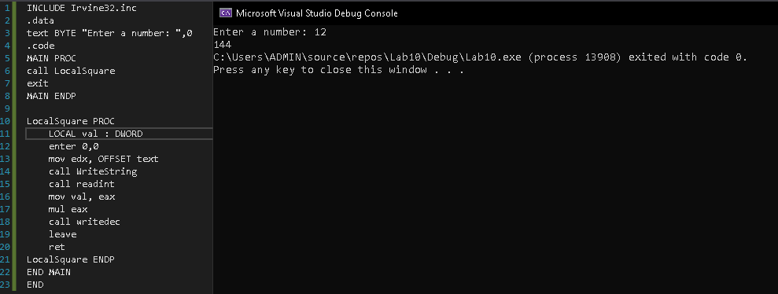

1. Write a program that calculates factorial of a given number ***n***. Make a recursive procedure named **Fact** that takes n as an input parameter.

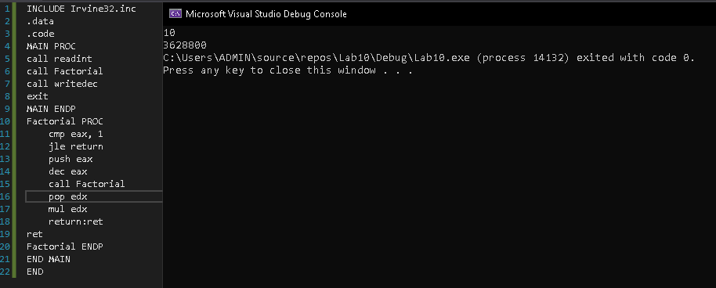

1. Write a program to take 4 input numbers from the users. Then make two procedures **CheckPrime** and **LargestPrime**. The program should first check if a given number is a prime number or not. If all of the input numbers are prime numbers then the program should call the procedure LargestPrime.

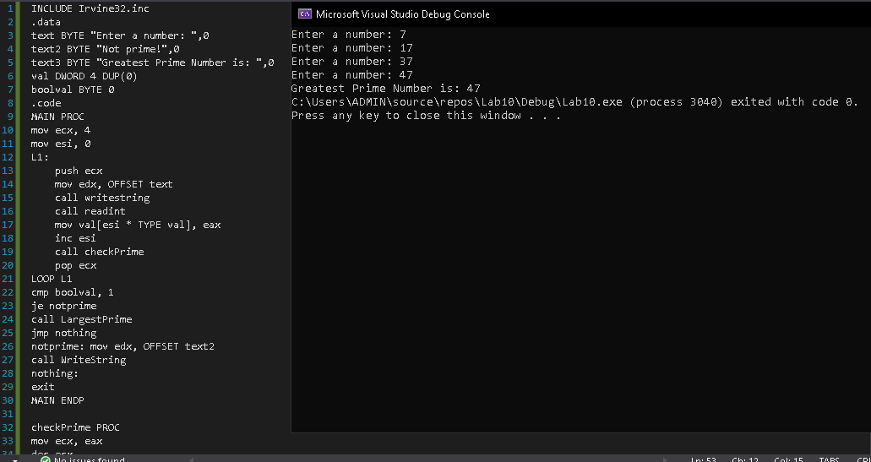

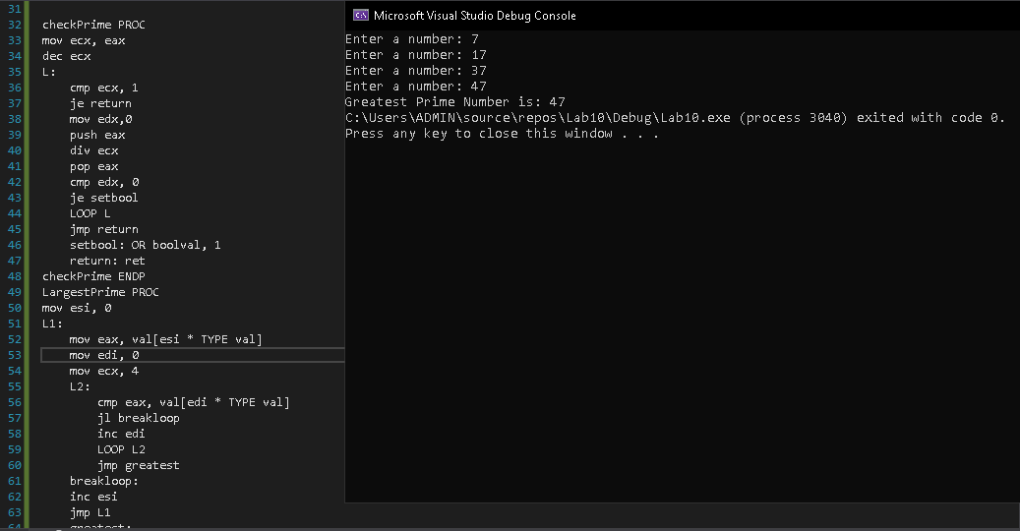

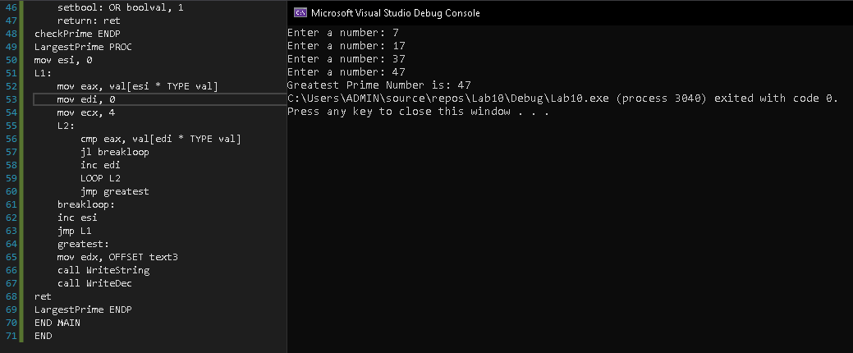

CheckPrime: This procedure tests if a number is prime or not

LargestPrime: This procedure finds and displays the largest of the four prime numbers.